**PROJECT DESIGN PHASE-II**

**TECHNOLOGY STACK (ARCHITECTURE & STACK)**

|  |  |
| --- | --- |
| **Date** | 26 October 2022 |
| **Team ID** | PNT2022TMID47589 |
| **Project Name** | Personal Assistance for Seniors who are Self-Reliant |
| **Maximum Marks** | 4 Marks |

**Technical Architecture:**

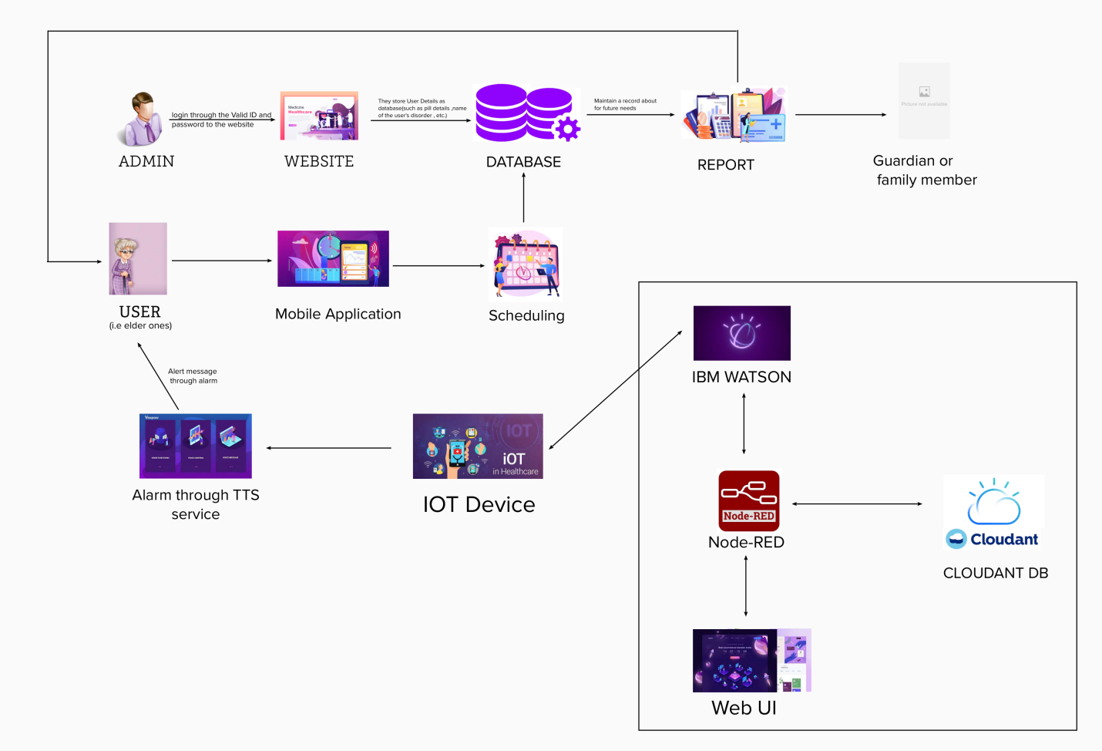

**TABLE-1 : COMPONENTS & TECHNOLOGIES:**

|  |  |  |  |
| --- | --- | --- | --- |
| **S.No** | **Component** | **Description** | **Technology** |
|  | User Interface | How user interacts with application | HTML, CSS, JavaScript / Angular Js / React Js. |
|  | Application Logic-1 | Logic for a process in the application | Python |
|  | Application Logic-2 | Logic for a process in the application | TTS service |
|  | Application Logic-3 | Logic for a process in the application | IBM Watson |
|  | Database | Data Type, Configurations etc. | MySQL |
|  | Cloud Database | Database Service on Cloud | IBM Cloudant |
|  | File Storage | File storage requirements | IBM Block Storage or Other Storage Service or Local Filesystem |
|  | External API-1 | Purpose of External API used in the application | Medical Report of the patient |
|  | Infrastructure (Server / Cloud) | Application Deployment on Local System / Cloud  Local Server Configuration:  Cloud Server Configuration : | Local, Cloud Foundry, Kubernetes, etc. |

**TABLE-2: APPLICATION CHARACTERISTICS:**

| **S.No** | **Characteristics** | **Description** | **Technology** |
| --- | --- | --- | --- |
|  | Open-Source Frameworks | List the open-source frameworks used | Technology of Opensource framework |
|  | Security Implementations | List all the security / access controls implemented, use of firewalls etc. | Encryptions, IAM Controls, OWASP etc. |
|  | Scalable Architecture | Justify the scalability of architecture (3 – tier, Micro-services) | Technology used |
|  | Availability | Justify the availability of application (e.g. use of load balancers, distributed servers etc.) | Technology used |
|  | Performance | Design consideration for the performance of the application (number of requests per sec, use of Cache, use of CDN’s) etc. | Technology used |